WEEK-1

AIM: Show version control with respective login credentials in GIT and GITHUB using simple html code.
GIT (Global Information Tracker)
While working on GIT, we actively use two repositories.
- GIT: Local repository: The local repository is present on our work space or in our computer and consists of all the files in a folder. This repository is used to create a file or make changes locally, adding those files to staging area and commit them as offline to review history.
- Github: Remote repository refers to the server repository that you may access it anywhere. This repository is used by all the team members to exchange the changes they made. Collaborate
Steps to follow to execute 1st week program by creating repositories
Step1: Open any text editor like visual studio, create a folder as Week-1 (user defined)
Step2: Create 2 HTML Files as One.html and Two.html file Week-1 folder, write below code, and save it.
One.html
<!DOCTYPE html>
<html lang="en">
<head>
<title>Git File One</title>
</head>
<body>
<h1>Hello CMR!</h1>
</body>
</html>

Two.html
<!DOCTYPE html>
<html lang="en">
<head>
<title> Git File Two</title>
</head>
<body>
<h2>We are from CSD-C</h2>
</body>
</html>

PS D:\Yamuna\Week-1> git version
git version 2.52.0.windows.1
PS D:\Yamuna\Week-1> git init
Initialized empty Git repository in D:/Yamuna/Week-1/.git/
PS D:\Yamuna\Week-1> git status
On branch master
No commits yet
Untracked files:
(use "git add <file>..." to include in what will be committed)
One.html
Two.html
nothing added to commit but untracked files present (use "git add" to track)
PS D:\Yamuna\Week-1> git add One.html Two.html
PS D:\Yamuna\Week-1>
PS D:\Yamuna\Week-1> git status
On branch master
No commits yet
Changes to be committed:
(use "git rm --cached <file>..." to unstage)
new file: One.html
new file: Two.html
PS D:\Yamuna\Week-1> git config --global user.name "Yamuna"
PS D:\Yamuna\Week-1>
PS D:\Yamuna\Week-1> git config --global user.email "msg2yamuna@cmritonline.ac.in"
PS D:\Yamuna\Week-1>
PS D:\Yamuna\Week-1> git commit -m "FirstCommit"
[master (root-commit) becfe05] FirstCommit
2 files changed, 0 insertions(+), 0 deletions(-)
create mode 100644 One.html
create mode 100644 Two.html
PS D:\Yamuna\Week-1>
PS D:\Yamuna\Week-1> git status
On branch master
nothing to commit, working tree clean
PS D:\Yamuna\Week-1>git remote add origin https://github.com/YamunaCMR/FSD-Week1.git
PS D:\Yamuna\Week-1>
PS D:\Yamuna\Week-1> git branch
* master
PS D:\Yamuna\Week-1> git push -u origin master
info: please complete authentication in your browser...
Enumerating objects: 3, done.
Counting objects: 100% (3/3), done.
Delta compression using up to 4 threads
Compressing objects: 100% (2/2), done.
Writing objects: 100% (3/3), 224 bytes | 74.00 KiB/s, done.
Total 3 (delta 0), reused 0 (delta 0), pack-reused 0 (from 0)
To https://github.com/YamunaCMR/FSD-Week1.git
* [new branch] master -> master
branch 'master' set up to track 'origin/master'.
PS D:\Yamuna\Week-1>
Note: Refresh the Github account, the output will be
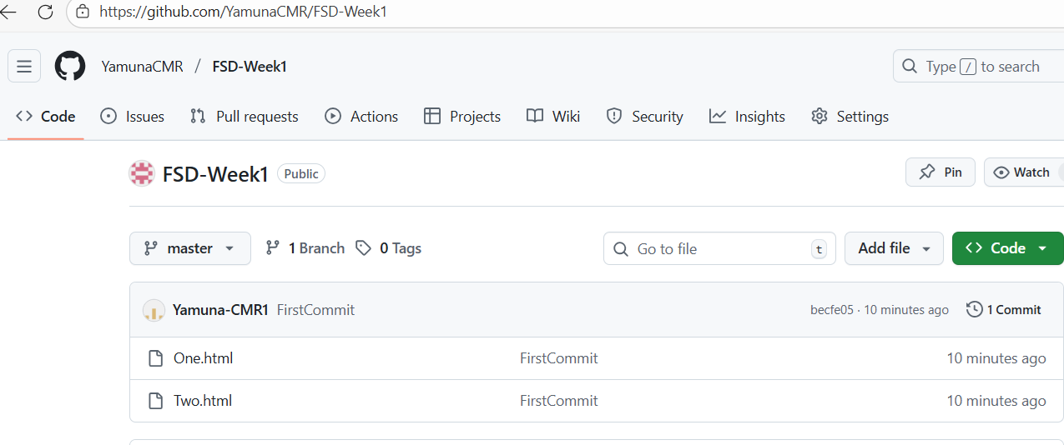
To copy total Week-1 project into Sample Folder

PS D:\Yamuna\Week-1> cd..
PS D:\Yamuna> md Sample

Directory: D:\Yamuna
Mode LastWriteTime Length Name
---- ------------- ------ ----
d----- 12/31/2025 12:57 PM Sample
PS D:\Yamuna> cd Sample
PS D:\Yamuna\Sample> git init
Initialized empty Git repository in D:/Yamuna/Sample/.git/
PS D:\Yamuna\sample> git clone https://github.com/YamunaCMR/FSD-Week1.git
Cloning into 'FSD-Week1'...
remote: Enumerating objects: 3, done.
remote: Counting objects: 100% (3/3), done.
remote: Compressing objects: 100% (2/2), done.
remote: Total 3 (delta 0), reused 3 (delta 0), pack-reused 0 (from 0)
Receiving objects: 100% (3/3), done.
Note: Now check, whether FSD-Week-1 project is available in Sample folder or not
PS D:\Yamuna\sample> ls
Directory: D:\Yamuna\sample
Mode LastWriteTime Length Name
---- ------------- ------ ----
d----- 12/31/2025 1:00 PM FSD-Week1
PS D:\Yamuna\sample\FSD-Week1> ls
Directory: D:\Yamuna\sample\FSD-Week1
Mode LastWriteTime Length Name
---- ------------- ------ ----
-a---- 12/31/2025 1:00 PM 0 One.html
-a---- 12/31/2025 1:00 PM 0 Two.html

MERGING AND BRANCHING

PS D:\Yamuna\sample\FSD-Week1>cd ..
PS D:\Yamuna\Sample>cd ..
PS D:\Yamuna>cd Week-1
PS D:\Yamuna\Week-1>
To Create a Branch

PS D:\Yamuna-FSD> git branch Developer1
PS D:\Yamuna-FSD> git checkout Developer1
PS D:\Yamuna\Week-1> git branch
* Developer1 ………….Now you are in Developer1 branch
master
Switched to branch 'Developer1'
Developer has created a file as three.html
Three.html
<!DOCTYPE html>
<html lang="en">
<head>
<title> Git File Three</title>
</head>
<body>
<h2>This is Developer1 File</h2>
</body>
</html>

PS D:\Yamuna-FSD> git add three.html
PS D:\Yamuna-FSD> git commit -m "Three"
[Developer1 16a3b7e] Three
1 file changed, 1 insertion(+)
create mode 100644 three.html

PS D:\Yamuna-FSD> git push origin Developer1
Enumerating objects: 4, done.
Counting objects: 100% (4/4), done.
Delta compression using up to 4 threads
Compressing objects: 100% (2/2), done.
Writing objects: 100% (3/3), 307 bytes | 102.00 KiB/s, done.
Total 3 (delta 0), reused 0 (delta 0), pack-reused 0 (from 0)
remote:
remote: Create a pull request for 'Developer1' on GitHub by visiting:
remote: https://github.com/YamunaCMR/FSD-Week1/pull/new/Developer1
remote:
To https://github.com/YamunaCMR/FSD-Week1.git
* [new branch] Developer1 -> Developer1

PS D:\Yamuna\Week-1> git push origin master
Everything up-to-date
PS D:\Yamuna\Week-1> git checkout master
Switched to branch 'master'
Your branch is up to date with 'origin/master'.
PS D:\Yamuna\Week-1> git merge developer1
Updating becfe05..16a3b7e
Fast-forward
three.html | 1 +
1 file changed, 1 insertion(+)
create mode 100644 three.html
PS D:\Yamuna\Week-1>

Note: Refresh the Github account, check whether three.html file is added or not

